**Niagara Falls City School District**

***4th Grade Physical Education Resources***

**Ms. Tripi – Niagara Street School/Hyde Park P.E.**

**P.E Activities for APRIL 27th- 1st**

**Grade Level: 4th Grade Email:** [**Stripi@nfschools.net**](mailto:Stripi@nfschools.net)

**Lesson Title: Fitness Lesson #4**

**\*This lesson should be completed at least twice during the week listed above\***

**NYS P.E. Standard #1 --** *Students will have the necessary knowledge and skills to establish and maintain physical fitness, participate in physical activity, and maintain personal health.*

**Warm-Up- Flip It**

* **Directions using a plastic water bottle see how your water bottle lands on the floor. You will flip the water bottle while you are sitting on the ground and the way that it falls will give you the exercise you should perform. The picture shows a cone but we are using a water bottle.**

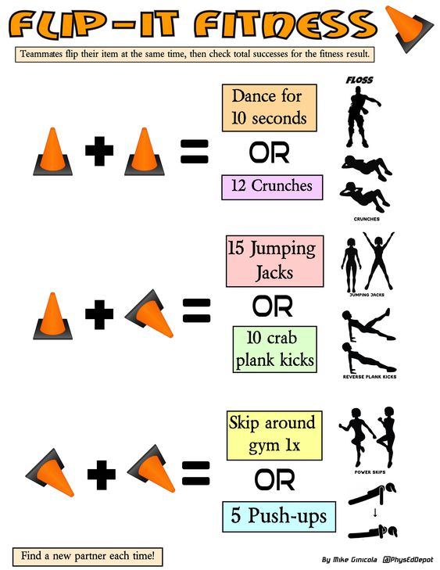

**Activity – Tic – Tac – Toe Fitness**

* Directions – You can play with someone in your house. One person is “X” and the other person is “O”. The person who marks their spot must do the exercise or skill that is on the board. Here is an example one. You may make your own at home as well.

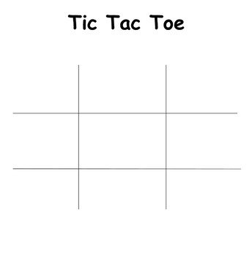

Throw an a ball in 20 Jumping Jacks 10 push ups

The air ten times.

Jog in place for a 15 line jumps

Minute. 20 air squats

Balance an object on 5 burpees 20 walking lunges

Your head for ten

Seconds.

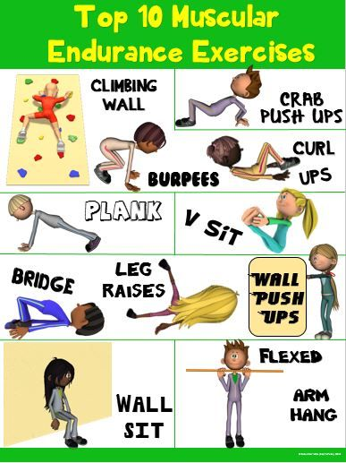**Cool Down – Stretches**

Butterfly pose

* Hold each stretch for 30 seconds